Jurnal JTIK (Jurnal Teknologi Informasi dan Komunikasi) 8 (1) 2024

Jurnal JTIK (Jurnal Teknologi Informasi dan Komunikasi)

Journal Homepage: http://journal.lembagakita.org/index.php/jtik

Analysis of The Millennial View on Insurance as a Key Financial Priority Using K-Means and Decision Tree
Giany Caroline Theresia Limanauw ¹, Raymond Sunardi Oetama ^{2*}
^{1,2*} Information Systems Study Program, Faculty of Engineering and Informatics, Universitas Multimedia Nusantara, Tangerang Regency, Banten Province, Indonesia.

a r t i c l e i n f o

Article history:
Received 30 July 2023 Received in revised form
23 November 2023
Accepted 10 December 2023
Available online January 2024

DOI: https://doi.org/10.35870/jtik.v8i1.1445.

Keywords:
Millennials; Insurance; Data Analysis; K-Means; Decision Tree.

Kata Kunci:
Generasi Milenial; Pertanggungan; Analisis Data; K-Means; Decision Tree.

ACM Computing Classification System (CCS)
Communication and Mass Media Complete (CMMC)
a b s t r a c t
Millennials, despite being the largest population segment in Indonesia, show little interest in insurance, with only 6-7% having coverage. This raises concerns about their financial preparedness and protection against unforeseen events. Many lack well-thought-out financial plans, focusing on immediate gratification and overlooking risk management, including insurance. This study aims to discover ways to revive millennials' awareness about the importance of insurance in achieving financial stability and well-being. This study employs a questionnaire for data collection and analyzes the data using k-means and decision tree algorithms. Based on the k-means algorithm and decision tree, it was found that many millennials lack insurance coverage. Reasons include lack of understanding, financial constraints, fear of deception, and considering insurance, not a priority. Young adults aged 21-29 showed a better understanding of insurance, but still, a significant portion remains uninsured. These insights can be used to develop educational programs and communication strategies that aim to bridge the awareness gap and increase insurance literacy among millennials.

a b s t r a k
Meskipun generasi milenial merupakan segmen populasi terbesar di Indonesia, mereka tidak begitu berminat terhadap asuransi, dimana hanya 6-7% yang memiliki asuransi. Hal ini menimbulkan kekhawatiran mengenai kesiapan finansial dan perlindungan mereka terhadap kejadian tak terduga. Banyak dari mereka yang tidak memiliki rencana keuangan yang matang, hanya berfokus pada kepuasan sesaat dan mengabaikan manajemen risiko, termasuk asuransi. Studi ini bertujuan untuk menemukan cara untuk menghidupkan kembali kesadaran generasi milenial tentang pentingnya asuransi dalam mencapai stabilitas dan kesejahteraan keuangan. Penelitian ini menggunakan kuesioner untuk pengumpulan data dan menganalisis data menggunakan algoritma k-means dan pohon keputusan. Berdasarkan algoritma k-means dan pohon keputusan, ditemukan banyak generasi milenial yang kekurangan perlindungan asuransi. Alasannya antara lain kurangnya pemahaman, kendala keuangan, takut ditipu, dan menganggap asuransi bukan prioritas. Orang dewasa muda berusia 21-29 tahun menunjukkan pemahaman yang lebih baik tentang asuransi, namun masih banyak orang yang belum memiliki asuransi. Wawasan ini dapat digunakan untuk mengembangkan program pendidikan dan strategi komunikasi yang bertujuan untuk menjembatani kesenjangan kesadaran dan meningkatkan literasi asuransi di kalangan generasi milenial.

*Corresponding Author. Email: raymond@umn.ac.id ^{2*}.

© E-ISSN: 2580-1643.
Copyright @ 2024 by the authors of this article. Published by Lembaga Otonom Lembaga Informasi dan Riset Indonesia (KITA INFO dan RISET). This work is licensed under a Creative Commons Attribution-NonCommercial 4.0 International License.

- Introduction

Insurance safeguards individuals and businesses from financial uncertainties. Insurance refers to a financial contract where individuals or businesses pay premiums to an insurer for protection against specified risks [1]. It offers financial coverage in case of unforeseen events, reducing potential losses and providing reassurance [2]. Health, life, auto, home, and travel insurance are common types. Policyholders can file claims for compensation when insured events occur. Insurance is crucial for risk management, ensuring financial security in challenging circumstances [3]. It offers protection, encourages long-term planning, and supports business continuity. Additionally, it contributes to social stability and complies with legal requirements [4]. The absence of insurance leaves individuals and businesses susceptible to financial insecurity, limited healthcare access, property and asset damages, legal and contractual complications, and diminished investment prospects [5]. It can lead to emotional strain and hinder recovery from unforeseen events, presenting significant risks to financial stability and well-being.

Insurance penetration in Indonesia, Vietnam, and the Philippines is comparatively lower than in other Asian countries [6]. Despite the Financial Services Authority (OJK) recognizing the significant role of the life insurance industry in the nation's development process, there is still a substantial gap in insurance coverage [7]. One striking observation is that millennials, who constitute the largest segment of the population in Indonesia, exhibit a lack of interest in insurance, with only 6-7% of them having insurance coverage [8]. This demographic group, born between the early 1980s and mid-1990s to early 2000s, plays a crucial role in shaping the nation's future. However, their underrepresentation in the insurance market raises concerns about their financial preparedness and protection against unforeseen events. Many young Indonesians have yet to establish well-thought-out financial plans. At a relatively young age, the majority tend to focus on immediate gratification and only realize the importance of financial planning for achieving early financial freedom later in life. Most millennials lack expenditure planning, fail to consider retirement and emergency funds, show indifference toward insurance, and more [9]. However, what particularly concerns me is their indifference toward insurance. As shown in Figure 1, referring to the financial pyramid from finansialku.com [10], insurance falls under risk management, ranking second in terms of priority when preparing financial plans. Regrettably, many millennials overlook risk management and proceed to investments, which ranks third in the pyramid.

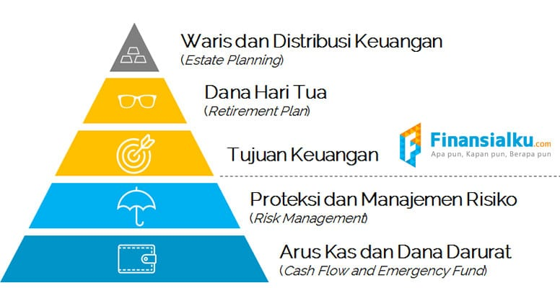
Figure 1. Financial Pyramid [10]

The generation that constitutes most of Indonesia's population, especially those in the productive age group, has resulted in a decline in insurance penetration, despite the significant role insurance plays in the country's economy. Millennials are accounted as the productive age group in Indonesia [11]. Due to the relatively low per capita income of Indonesian society, the interest in purchasing insurance services might be limited [12]. This percentage is expected to continue increasing and is projected to reach two-thirds of the overall population [13], yet it is not reflected in the insurance penetration rate in Indonesia.

As the insurance industry continues to grow and the population expands, the amount of data generated also increases exponentially. The sheer volume of data presents both a challenge and an opportunity. To derive meaningful insights and make informed decisions, it is essential to analyze this data effectively. This is where data analysis comes into play. This study aims to find solutions to reawaken the awareness of millennials regarding insurance, which should be considered vital in financial stability and well-being. Data analysis involves examining and interpreting vast and complex datasets to discover patterns, trends, and correlations. It encompasses the exploration of data to extract valuable information and actionable insights. Through data analysis, insurers can gain a deeper understanding of millennials' behavior, preferences, and needs. By examining datasets containing information on millennials' financial habits, online interactions, and lifestyle choices, insurance companies can uncover valuable insights. These insights can help insurers tailor their products and marketing strategies to resonate with the younger generation effectively. Through data analysis, insurers can identify the primary factors contributing to the lack of insurance awareness among millennials. They can discern patterns and trends related to millennials' understanding of insurance functions, which can inform educational initiatives and communication strategies to bridge the awareness gap.

- Methods

Research Object
The research object for this problem topic is the young generation of Indonesia, commonly known as the millennial generation. The targeted age range is from 18 to 30 years old. This age range was selected because, in general, most individuals in this age group are in their productive years, working, and at a stage where they should start considering financial planning for the future.

Data Collection Method
To obtain data, an online questionnaire is performed through Google Forms. Google Forms is commonly used to create surveys, forms, or research questionnaires that can be shared with the targeted respondents to gather data. The questionnaire consists of questions related to the views and understanding of insurance among the millennial generation in Indonesia. The sampling technique chosen is simple random sampling. This technique is the most basic, where every member of a population has an equal chance of becoming a sample in the research [14]. Simple random sampling requires a sampling frame to identify the location of the target samples. In this study, the sampling frame used is Indonesian millennials.

Algorithms
In this research, two algorithms were utilized to analyze the data obtained from the questionnaire. The first algorithm employed was clustering, with the specific implementation of k-means to determine the clusters. Clustering is a method that involves grouping a diverse set of objects or data points into distinct clusters based on their similarities. Each cluster comprises objects or data that share significant similarities while being distinct from objects in other clusters. The goal is to create groups that are as internally homogenous as possible while being externally different from one another [15]. The k-means algorithm functions as follows:
- Determine the desired number of clusters, denoted as "k."
- Randomly initialize k centroids, which represent the initial cluster centers.
- Calculate the distance between each data point and each centroid.
- Assign each data point to the nearest centroid, forming the initial clusters.
- Recalculate the positions of the centroids by computing the average of the data points belonging to each cluster.
- Repeat steps 3 to 5 until the positions of the centroids remain stable or converge.

The application of clustering with the k-means algorithm is beneficial in this research, as it aids in organizing the data and segregating respondents into meaningful groups based on their responses. This segmentation enables a more focused analysis of insurance perceptions and priorities among different age groups, facilitating targeted strategies and interventions to enhance insurance awareness and adoption among millennials. The k-means algorithm is an effective tool in revealing hidden insights and guiding decision-making processes in the context of insurance planning and financial preparedness for the younger generation.

Furthermore, a Decision Tree is a tree-like arrangement, where each node corresponds to a tested attribute, branches depict the distribution of test outcomes, and leaf nodes indicate specific class categories. The highest-level node, known as the root, typically represents the attribute with the greatest influence on a particular class [16]. The function of the decision tree is to classify existing data, enabling predictions for new data by using the available data as a reference for categorization and predicting the research outcome. Additionally, the decision tree can identify relationships between input variables and the target variable. Apart from its uses, the decision tree algorithm also has some advantages. Its advantages include higher accuracy in providing prediction results, simplifying complex decision-making processes, and handling both numerical and categorical data. Furthermore, the results are easily interpretable and understandable by humans. The decision tree is then created using the party library using R programming.

- Results and Analysis

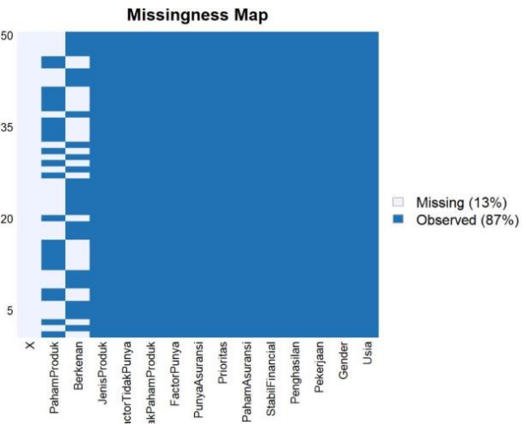
Figure 2. Missingness Map

Based on the missingness map as shown in Figure 2, the data collected from the questionnaire with 50 respondents shows a missingness rate of 13%. This occurred because one specific question was divided into two parts to address different groups of respondents. The first part of the question was directed toward respondents who already insurance have, while the second part was aimed at respondents who do not have insurance. Due to this division, respondents who belonged to one group were not required to answer the questions intended for the other group, resulting in missing data.

From the data gathered from 50 respondents aged between 17 to 29 years old, it was observed that the understanding of insurance varies among different age groups. As shown in Figure 3, specifically, respondents within the age range of 18 to 21 years old generally lack a comprehensive understanding of insurance, while those in the age group of 21 to 29 years old mostly possess a good understanding of insurance. Regarding the variable "priority," the data indicate that some respondents between the ages of 17 to 24 years old do not consider insurance as a priority in their financial planning, while others are still uncertain about its importance and are considering it as a potential priority ("maybe"). As a result, most younger age groups have a relatively lower understanding of the importance of risk management in their financial planning. On the other hand, the older age groups, who mostly have higher incomes, show a better understanding of insurance to handle financial crises during emergencies.

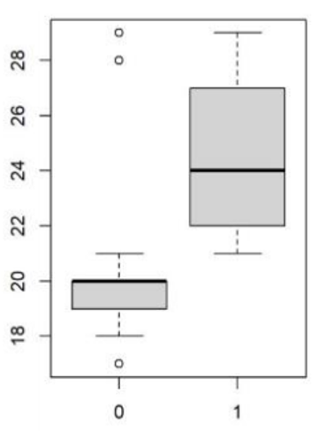
Figure 3. Boxplot of Understanding of Insurance based on Ages.

As depicted in Figure 4, the prioritization of insurance is categorized into three answers: 0 represents insurance not being prioritized, 1 indicates insurance is prioritized, and 2 denotes a "maybe" response. In the age group of 24 to 29 years old, a significant number of respondents prioritize insurance in their financial planning. This indicates that most individuals within this age range recognize the importance of having insurance coverage to safeguard their financial well-being. By making insurance a priority in their financial plans, they are taking proactive steps to protect themselves and their assets from unforeseen events and potential risks. This decision reflects a sense of financial responsibility and long-term planning, as insurance provides a safety net during challenging times and helps ensure a more secure financial future. In the data analysis, several outliers were identified in both the age groups that lack an understanding of insurance and the age groups that are considering insurance as a potential priority. These outliers might represent unique cases or extreme responses that deviate significantly from most respondents in their respective age groups. The presence of outliers can provide valuable insights and may warrant further investigation to understand the underlying reasons behind their responses.

Based on the results depicted in Figure 5, it is evident that the understanding of insurance among the respondents exhibits more distinct variations or separations. Therefore, this variable, which represents the respondents' level of comprehension regarding insurance, will be chosen as the target or dependent variable in the Decision Tree analysis. By using the understanding of insurance as the target variable, the Decision Tree algorithm will attempt to identify patterns and relationships between different attributes and the respondents' comprehension levels. It will create a tree-like structure with nodes representing tested attributes and branches showing the distribution of responses. The Decision Tree will then use this structure to classify respondents into specific groups based on their understanding of insurance.

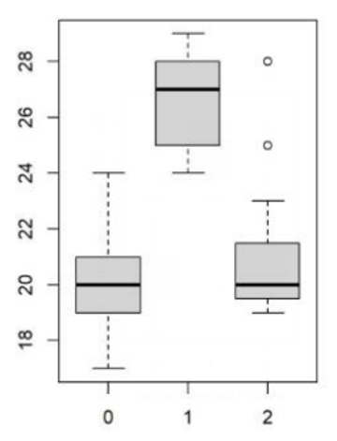
Figure 4. Boxplot of Level of Priority of Insurance based on Ages.

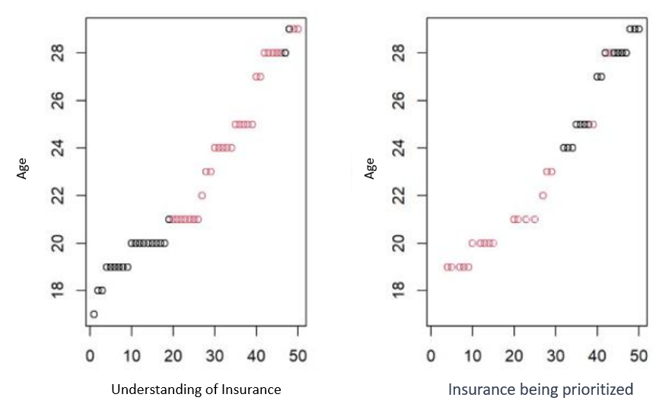
Figure 5. Clustering using K Means

Moreover, employing the decision tree algorithm appears to provide more clarity compared to the initial algorithm used. From the results of the decision tree analysis presented in Figure 6, among respondents, 29 individuals understand insurance, and 21 individuals do not. It becomes evident that within the age range of teenagers to young adults, particularly from 18 to 21 years old with a mean age of 20 years and outliers at ages 17, 28, and 29, there is a lack of understanding regarding the importance of insurance. This finding suggests that individuals in this age group may not fully grasp the significance of having insurance coverage in their financial plans. Conversely, for the age group that demonstrates an understanding of insurance, the majority falls within the young adult age range, specifically from 21 to 29 years old with a mean age of 24 years, and no outliers were identified. This indicates that young adults in this age bracket are more likely to comprehend the importance of insurance and are potentially more proactive in considering it as a crucial component of their financial preparedness.

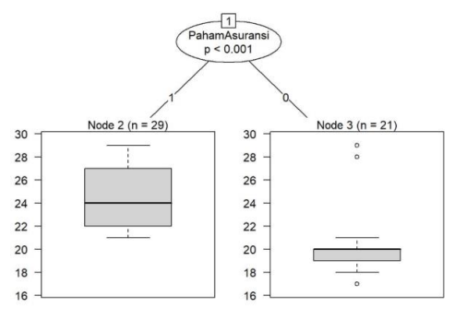
Figure 6. Decision Tree Based on Understanding of Insurance

The decision tree analysis allows for a more granular examination of the relationship between age and understanding of insurance. By visually depicting the distinctions between age subgroups, it becomes easier to identify trends and patterns in insurance comprehension. This information can be invaluable in tailoring educational initiatives and outreach programs aimed at enhancing insurance awareness among the younger population. Additionally, it enables targeted efforts to bridge the gap in insurance understanding among various age cohorts, ultimately promoting better financial planning and risk management for the future.

Table 1. Understanding of Insurance
Have Insurance | Reasons | %
Yes  23.33% | Need Insurance | 71.43%
 | Recommendation from family or friend | 28.57%
No  76.67% | Afraid of being deceived | 30.43%
 | Cannot afford | 26.09%
 | It is not a priority | 17.39%
 | Still young | 13.04%
 | Uncomfortable with insurance agents | 8.70%
 | Not sure about insurance products | 4.35%

Table 1 illustrates the respondents' understanding of insurance based on whether they have insurance or not. More individuals are still without insurance. Among those who have insurance, 71.43% mentioned that they needed insurance, and 28.57% were influenced by recommendations from family or friends. For respondents without insurance, 30.43% expressed fear of being deceived, 26.09% cited financial constraints, and 17.39% considered insurance not a priority. Additionally, 13.04% felt they were too young to think about insurance, 8.70% were uncomfortable with insurance agents, and 4.35% were unsure about insurance products. The data reveals the diverse reasons influencing respondents' decisions regarding insurance, suggesting a need for increased awareness and education about insurance products and their benefits.

- Conclusion & Recommendations

Based on the k-means algorithm, two clusters were identified: millennials who understand insurance and millennials who do not. Based on a decision tree, for the age group that demonstrates an understanding of insurance, the majority falls within the young adult age range, specifically from 21 to 29 years old. Among those who understand insurance, the majority have insurance based on their needs 71.43%. However, many millennials still do not have insurance. Among those who understand insurance but lack coverage, reasons include fear of being deceived, financial constraints, and considering insurance not a priority. Others mentioned feeling too young to think about insurance, discomfort with insurance agents, and uncertainty about insurance products. Based on the findings of the research above, it can be concluded that many millennials are still neglecting the importance of sound financial planning. This is particularly evident among young adults who are mostly pursuing education or attending college. The reasons for the lack of insurance coverage among this younger generation, as identified in the survey conducted for this study, include a lack of understanding of insurance functions, inability to afford insurance premiums, fear of being deceived due to recent cases of insurance companies failing to pay customer claims, and some individuals believing they do not need insurance because they think they will not get sick or fear financial losses.

For Indonesian educational institutions, basic financial literacy education should be provided, starting from the lower or upper secondary levels. By being equipped with essential financial knowledge early on, young individuals will be better prepared to navigate financial planning and decision-making as they grow older. Topics such as budgeting, saving, investing, understanding insurance, and managing debt should be covered, empowering millennials to make informed financial choices. For All millennials, it is strongly encouraged to actively seek out information about financial literacy from an early age. Workshops, books, educational videos, or consultations with financial advisors can be attended and sought. By increasing your financial knowledge, a better understanding of important concepts and strategies can be developed, financial pitfalls can be avoided, and financial stability can be ensured in the long run.

- Acknowledgments

Gratitude is extended to Multimedia Nusantara University for their financial support and guidance from faculty members, which have been instrumental in the completion of this research.

- References

- Kunreuther, H. and Schupp, J., 2021. Evaluating the Role of Insurance in Managing Risk of Future Pandemics (No. w28968). National Bureau of Economic Research.

- Lin, X. and Kwon, W.J., 2020. Application of parametric insurance in principle‐compliant and innovative ways. Risk Management and Insurance Review, 23(2), pp.121-150. DOI: https://doi.org/10.1111/rmir.12146.

- Richter, A. and Wilson, T.C., 2020. Covid-19: implications for insurer risk management and the insurability of pandemic risk. The Geneva risk and insurance review, 45(2), pp.171-199. DOI: https://doi.org/10.1057/s10713-020-00054-z.

- Chen, B., Liu, T., Guo, L. and Xie, Z., 2020. The disembedded digital economy: Social protection for new economy employment in China. Social Policy & Administration, 54(7), pp.1246-1260. DOI: https://doi.org/10.1111/spol.12603.

- Bieber, F. and Moggia, J., 2021. Risk shifts in the gig economy: The normative case for an insurance scheme against the effects of precarious work. Journal of Political Philosophy, 29(3), pp.281-304.

- Ng, J.Y.S., Ramadani, R.V., Hendrawan, D., Duc, D.T. and Kiet, P.H.T., 2019. National health insurance databases in Indonesia, Vietnam and the Philippines. PharmacoEconomics-open, 3, pp.517-526. DOI: https://doi.org/10.1007/s41669-019-0127-2.

- Fadah, I., Putri, I.F., Ulfa, L. and Budi, I., 2021, December. Determinants of Performance of Sharia Insurance Registered at OJK. In Prosiding International Conference on Sustainable Innovation (ICoSI) (Vol. 1, No. 2, pp. 15-20).

- Bubun, U.U. and Irawan, J.L., 2023. Identification of Perceptions and Levels of Health Insurance Literacy in Makassar Metropolitan Millennials. JManagER, 2(02), pp.35-50.

- Rif’ah, S., 2019. Fenomena Cashless Society Di Era Milenial Dalam Perspektif Islam. Al-Musthofa: Journal of Sharia Economics, 2(1), pp.1-14.

- Financialku.com., 2021. Piramida Perencana Keuangan: Menentukan Prioritas Keuangan. URL: https://www.finansialku.com/piramida-perencana-keuangan-menentukan-prioritas-keuangan-pkirt0103/

- Suprapto, Y., 2020. Analysis of factors affecting the use of cashless mobile payment in millenial generations of Batam City. Journal of Business Studies and Mangement Review, 4(1), pp.59-65. DOI: https://doi.org/10.22437/jbsmr.v4i1.10748.

- Pakpahan, B., Batubara, J.Y., Sembiring, B., Sibarani, H.J. and Sipayung, S.M.N., 2023. The Effect of Personal Selling, Premium Prices, and Income Levels on Interest in Buying Insurance Products in (Case Study on Millennial Generation and Gen-Z in Medan City). International Journal Of Economics Social And Technology, 2(3), pp.151-159. DOI: https://doi.org/10.59086/ijest.v2i3.322.

- Bansal, S., Bruno, P., Denecker, O., Goparaju, M. and Niederkorn, M., 2018. Global payments 2018: A dynamic industry continues to break new ground. Global Banking McKinsey.

- Iliyasu, R. and Etikan, I., 2021. Comparison of quota sampling and stratified random sampling. Biom. Biostat. Int. J. Rev, 10(1), pp.24-27.

- Nainggolan, R., Tobing, F.A.T. and Harianja, E.J., 2022. Sentiment; Clustering; K-Means Analysis Sentiment in Bukalapak Comments with K-Means Clustering Method. IJNMT (International Journal of New Media Technology), 9(2), pp.87-92. DOI: https://doi.org/10.31937/ijnmt.v9i2.2914.

- Yunus, W., Desanti, R.I. and Wella, W., 2020. Data Visualization And Sales Prediction of PD. Asia Agung (Ajinomoto) Pontianak in 2019. IJNMT (International Journal of New Media Technology), 7(2), pp.51-57. DOI: https://doi.org/10.31937/ijnmt.v7i2.1697.

